Growth Dynamics: A Crucial Emphasis at Our World in Data using Power BI

Introduction:
In the realm of data visualization and analysis, Growth Dynamics stands as a crucial emphasis at Our World in Data, leveraging the power of tools like Power BI. Growth Dynamics refers to the examination and understanding of patterns, trends, and changes in various phenomena over time. Whether it's population growth, economic expansion, disease prevalence, or environmental shifts, grasping the dynamics of growth is essential for informed decision-making and policy formulation.
With Power BI, Our World in Data can delve into vast datasets, extracting valuable insights and presenting them in intuitive visualizations. By focusing on Growth Dynamics, they can effectively communicate complex trends, highlight disparities, and track progress towards global goals such as sustainable development and public health.
Scenario 1: COVID-19 Pandemic Response:
Our World in Data employs Power BI to track the growth dynamics of COVID-19 cases, deaths, and vaccination rates worldwide. Real-time data streams are integrated to provide up-to-date insights into the spread of the virus, enabling policymakers, healthcare professionals, and the public to make informed decisions. Through dynamic visualizations, trends in infection rates, vaccination coverage, and the effectiveness of containment measures are highlighted, aiding in the formulation of targeted interventions and resource allocation strategies.
Scenario 2: Climate Change Monitoring:
Utilizing Power BI, Our World in Data monitors the growth dynamics of key climate indicators such as greenhouse gas emissions, global temperatures, and sea level rise. Real-time data from satellites, weather stations, and scientific research are analyzed to visualize trends and patterns in environmental change. By presenting this information in interactive dashboards, stakeholders ranging from policymakers to environmental advocates can track the progress of mitigation efforts, identify vulnerable regions, and advocate for evidence-based climate policies.
Scenario 3: Global Economic Trends:
Our World in Data utilizes Power BI to analyze growth dynamics in global economic indicators such as GDP growth, income inequality, and employment rates. Real-time data from international organizations, central banks, and statistical agencies are processed to identify emerging trends and disparities across regions and socioeconomic groups. Through visually compelling dashboards, decision-makers in finance, government, and business can gain insights into economic resilience, market dynamics, and the impact of policy interventions, guiding efforts towards inclusive and sustainable growth.

Technical Architecture:

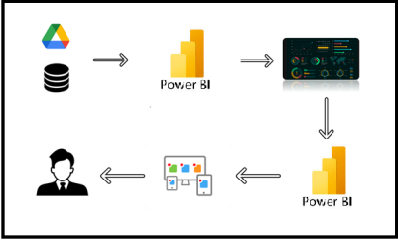

Project Flow
To accomplish this, we have to complete all the activities listed below,
- Data Collection
  - Collect the dataset,
  - Connect Data with Power BI
- Data Preparation
  - Prepare the Data for Visualization
- Data Visualizations
  - Visualizations
- Dashboard
  - Responsive and Design of Dashboard
- Report
- Report Creation
- Performance Testing
  - Amount of Data Rendered to DB
  - Utilization of Data Filters
  - No. of Calculation fields
  - No. of Visualizations/Graphs
- Project Demonstration & Documentation
  - Record explanation Video for project end to end solution
  - Project Documentation-Step by step project development procedure

Milestone 1: Data Collection & Extraction from Database

Data collection is the process of gathering and measuring information on variables of interest, in an established systematic fashion that enables one to answer stated research questions, test hypotheses, evaluate outcomes and generate insights from the data.

Activity 1: Downloading the dataset
Please use the link to download the dataset: Link

Activity 1.1: Understand the data
Data contains all the meta information regarding the columns described in the CSV files
Column Description of the Dataset:
- Country Name
- Year
- Population
- Population of children under the age of 1
- Population of children under the age of 5
- Population of children under the age of 15
- Population under the age of 25
- Population aged 15 to 64 years
- Population older than 15 years
- Population older than 18 years
- Population at age 1
- Population aged 1 to 4 years
- Population aged 5 to 9 years
- Population aged 10 to 14 years
- Population aged 15 to 19 years
- Population aged 20 to 29 years
- Population aged 30 to 39 years
- Population aged 40 to 49 years
- Population aged 50 to 59 years
- Population aged 60 to 69 years
- Population aged 70 to 79 years
- Population aged 80 to 89 years
- Population aged 90 to 99 years
- Population older than 100 years

Milestone 2: Data Preparation

Preparing the data for visualization involves cleaning the data to remove irrelevant or missing data, transforming the data into a format that can be easily visualized, exploring the data to identify patterns and trends, filtering the data to focus on specific subsets of data, preparing the data for visualization software, and ensuring the data is accurate and complete.

Activity 1: Prepare the Data for Visualization

This process helps to make the data easily understandable and ready for creating visualizations to gain insights into the performance and efficiency. Since the data is already cleaned, we can move to visualization.

3.1: Data Loading :Data Loading.mp4

3.2 Data Cleaning : Data Cleaning.mp4

Milestone 3: Data Visualization

Data visualization is the process of creating graphical representations of data to help people understand and explore the information. The goal of data visualization is to make complex data sets more accessible, intuitive, and easier to interpret. By using visual elements such as charts, graphs, and maps, data visualizations can help people quickly identify patterns, trends, and outliers in the data.

Activity 1: Visualizations

Activity 1.1: Total Population

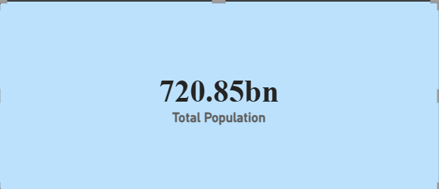

Activity 1.2: Kid’s Population

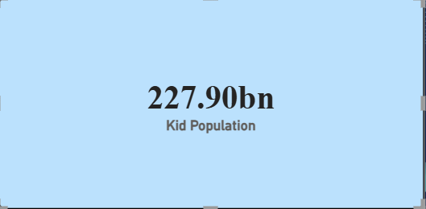

Activity 1.3: Youth Population
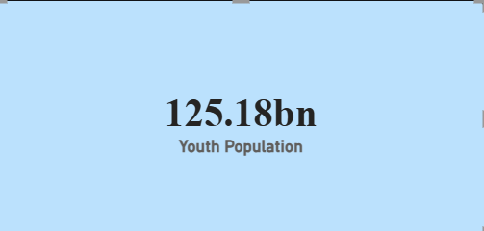

Activity 1.4: Adult Population
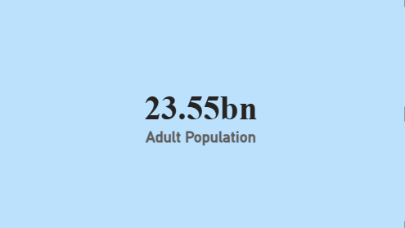

Activity 1.5: Senior Population
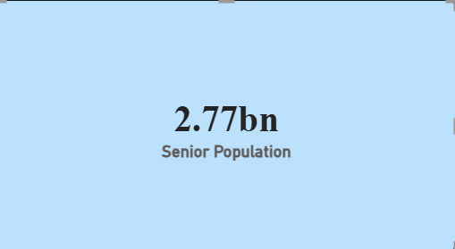

Activity 1.6: Top 5 Countries – Kid Population
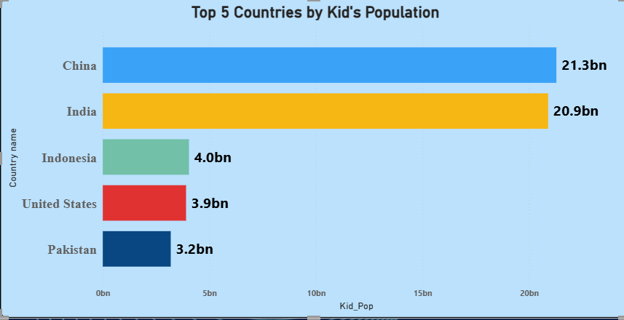

Activity 1.7: Adult Population by Year
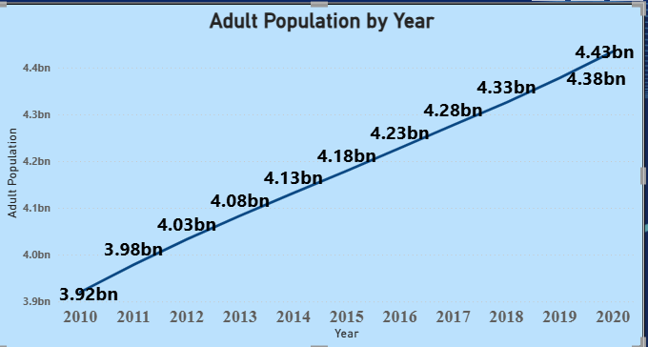

Activity 1.8: Least 5 Countries by Youth Population
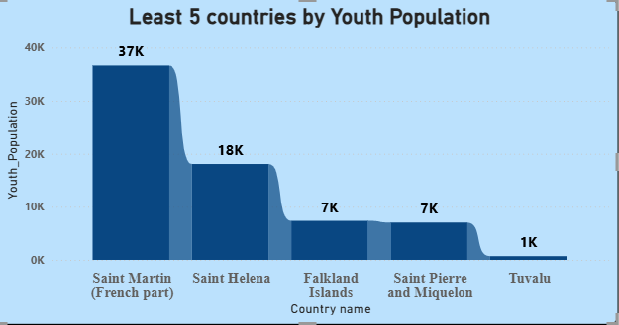

Activity 1.9: Senior Population by Year and Country
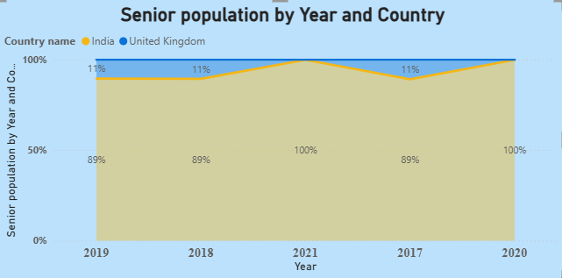
Activity 1.10: Top 5 Countries with Highest Population
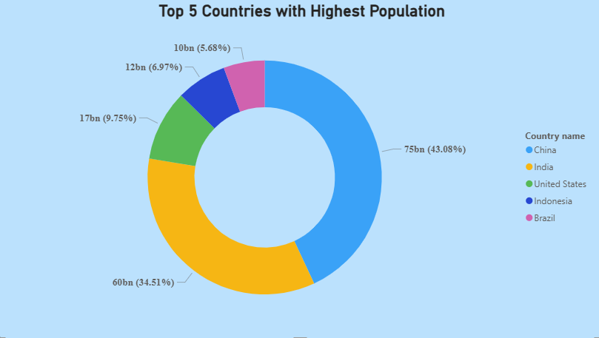

Activity 1.11: Top 5 Countries Population by Age Group
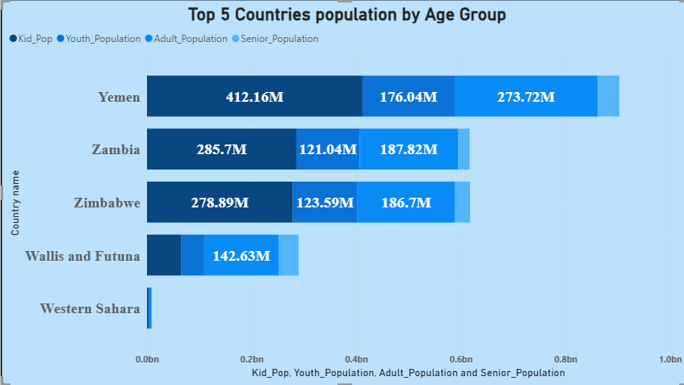

Activity 1.12: Total Population by Year
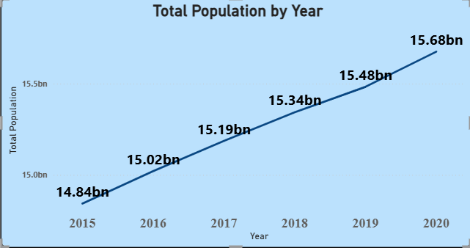

Activity 1.13: Age Composition Year
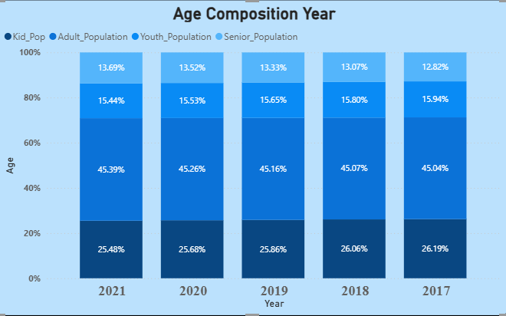

Activity 1.14: Least 5 Countries by Population
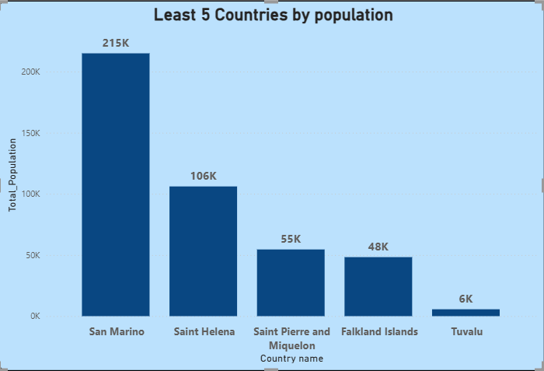
Activity 1.15: Population Breakdown Analysis
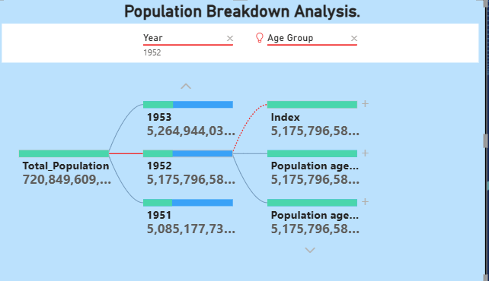

NOTE: Video Explanations for the above Visualizations are in Dashboard and Report sections.

Milestone 4: Dashboard
A dashboard is a graphical user interface (GUI) that displays information and data in an organized, easy-to-read format. Dashboards are often used to provide real-time monitoring and analysis of data and are typically designed for a specific purpose or use case. Dashboards can be used in a variety of settings, such as business, finance, manufacturing, healthcare, and many other industries. They can be used to track key performance indicators (KPIs), monitor performance metrics, and display data in the form of charts, graphs, and tables.
Activity 1- Responsive and Design of Dashboard
Explanation video link:

Dashboard: Dashboard (2).mp4
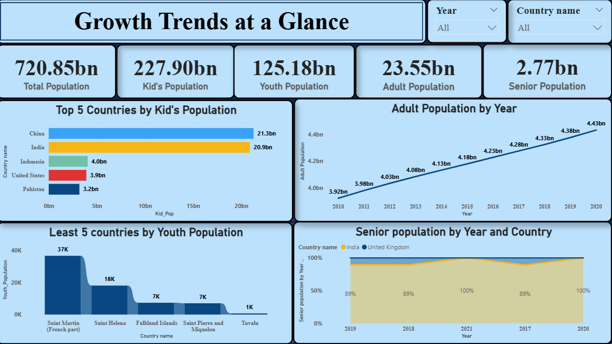

Milestone 5: Report
A report is a comprehensive document that provides a detailed and structured account of data analysis, findings, and insights. It is typically used for in-depth analysis, documentation, and communication of results. Reports are suitable for a diverse audience, including decision-makers, analysts, and stakeholders who need a comprehensive understanding of the data.

Activity 1: Design of Report

Designing a report in Power BI involves connecting to data sources, creating visualizations like charts and graphs, customizing their appearance and interactivity, organizing them logically on the canvas, formatting elements for consistency and clarity, and optionally creating dashboards for a summarized view. Throughout the process, it's essential to consider the audience's needs and ensure the report effectively communicates insights from the data. Finally, iterate based on feedback to continually improve the report's design and usefulness.

Explanation video link: Report 2.mp4

Report:

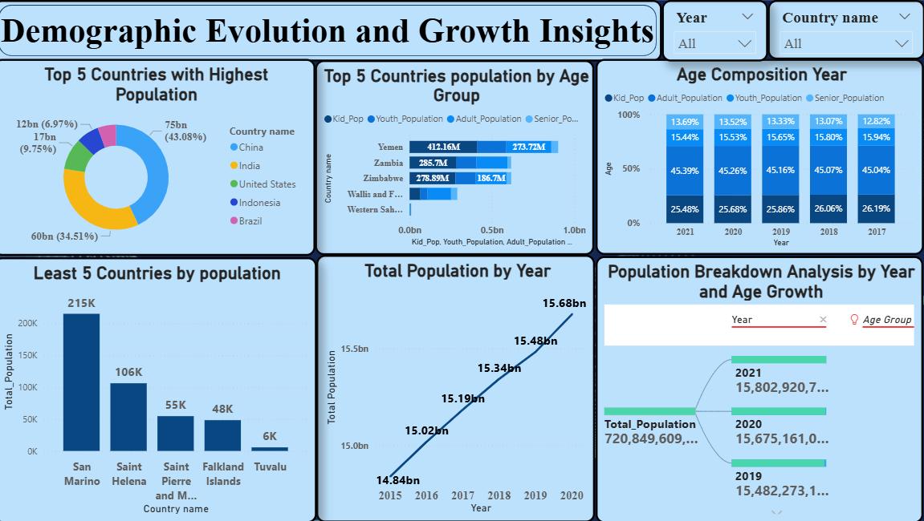

Milestone 6: Performance Testing
Performance testing is a crucial aspect of software development aimed at evaluating the speed, responsiveness, stability, and scalability of an application under various workload conditions. It involves simulating real-world usage scenarios to assess how the system behaves and performs under stress, peak loads, or normal conditions.

Activity 1: Amount of Data Loaded

"Amount of Data Loaded" refers to the quantity or volume of data that has been imported, retrieved, or loaded into a system, software application, database, or any other data storage or processing environment. It's a measure of how much data has been successfully processed and made available for analysis, manipulation, or use within the system.

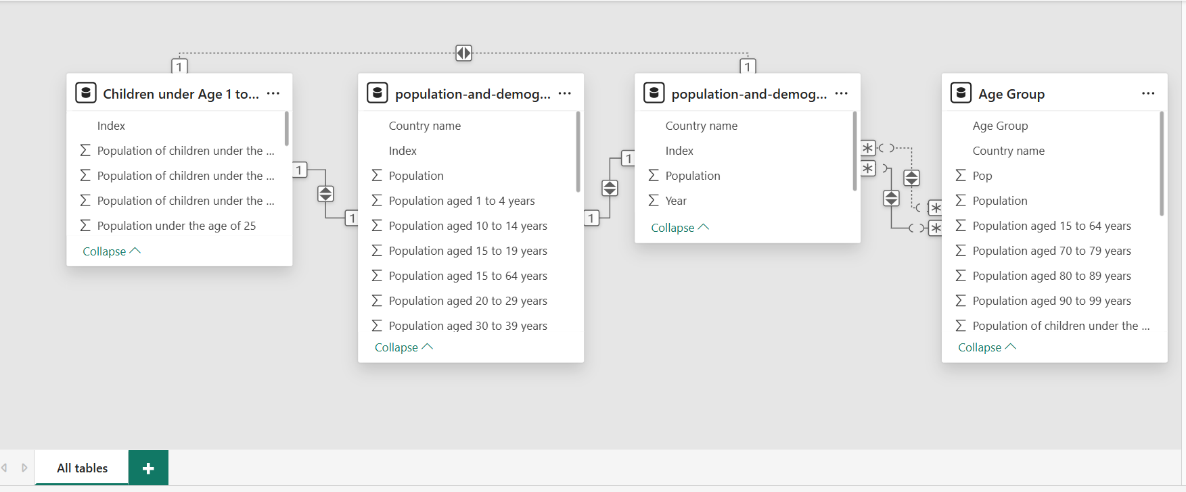

Activity 2: Utilization of Filters

"Utilization of Filters" refers to the application or use of filters within a system, software application, or data processing pipeline to selectively extract, manipulate, or analyze data based on specified criteria or conditions.

Activity 2.1: Selected Year as “2019”

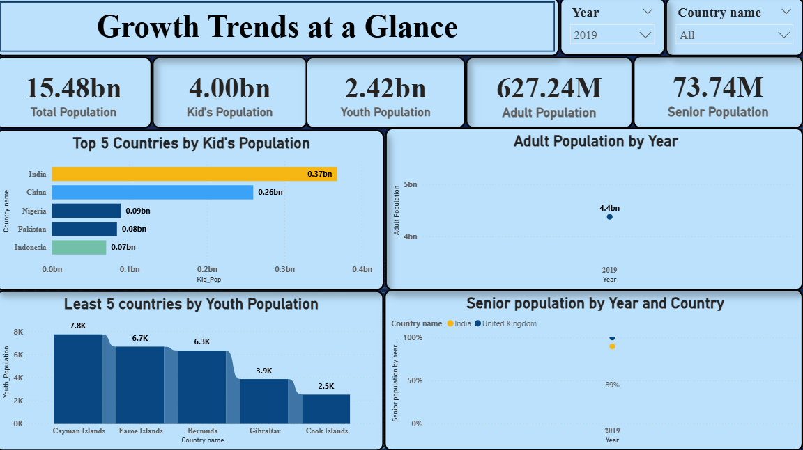

Activity 3: No of Visualizations/ Graphs

- Total Number of Population.
- Kid’s Population.
- Youth Population.
- Adult Population.
- Senior Population.
- Top 5 Countries by Kid Population.
- Adult Population by Year.
- Least 5 Countries by Youth Population.
- Senior Population by Year and Country .
- Top 5 Countries with Highest Population.
- Top 5 Countries Population by Age Group.
- Total Population by Year.
- Age Composition Year.
- Least 5 Countries by Population.
- Population Breakdown Analysis.

Milestone 7: Project Demonstration & Documentation
Below mentioned deliverables to be submitted along with other deliverables
Activity 1: - Record explanation Video for the project's end-to-end solution
Creating a record explanation video for a project's end-to-end solution is crucial for ensuring clarity and transparency in its implementation.
Activity 2: - Project Documentation-Step by step project development procedure
Create document as per the template provided

